Edward Christian Church Critical Spirit pt 6
"Criticism" GK- kritikos = "able to discern or skilled in judging."
- Criticism has two different meanings:
  - Speaking fairly with discernment in regard to merit or value
  - Speaking unfairly with trivial or harsh judgments- unfair criticism by faultfinding
The Bible stresses the powerful impact of our right and wrong words. ...
"The tongue has the power of life and death. ..." -Proverbs 18:21

What Is the Cycle of Criticism?
Job has had enough ... and hopes to quiet his "friends-turned-accusers" once and for all. "You, however, smear me with lies; you are worthless physicians, all of you! If only you would be altogether silent! For you, that would be wisdom" (Job 13:4-5). But the cycle of criticism continues ... all three accusers keep up the verbal pounding, which prompts this battered man to plead before his God ...
"Only grant me these two things, God, and then I will not hide from you: Withdraw your hand far from me, and stop frightening me with your terrors." (Job 13:20-21)
The painful situations we experience are processed by our soul — our mind, will, / emotions. Over time, we can develop a negative pattern of reacting to these painful situations (becoming critical), a pattern that can remain with us into and throughout our life. We must rely on the transforming work of the Holy Spirit within us to help us overcome a critical spirit.
When you are trapped in a cycle of critical thinking you may exclaim, "I can't help reacting this way!" Yet your emotions are merely responding to what your mind thinks. Therefore, the cycle is this: Your negative thoughts produce your negative emotions, which, in turn, produce your negative actions.
Since the cycle of criticism begins in our thoughts, we need to heed what the Bible tells us about renewing our minds and appropriate the mind of Christ. With God's help we can change our thoughts and then experience a changed life. Scripture says it this way ...
"'Who has known the mind of the Lord so as to instruct him?' But we have the mind of Christ. ... Do not conform to the pattern of this world, but be transformed by the renewing of your mind." (1 Cor 2:16; Romans 12:2)
Whenever a negative situation occurs in your life, you have a choice as to how you think about it — which determines how you respond. The natural progression occurs as follows:

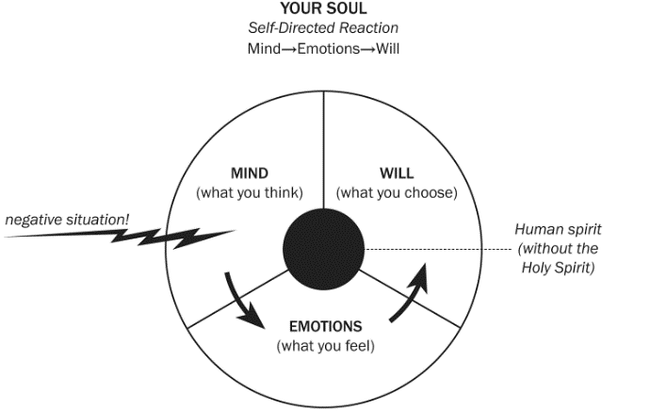
Negative Situation: Someone verbally cuts you down.

Natural Human Response
- Your Mind records the cruel words and thinks angry thoughts. ("He's so hateful.")
Many develop a critical spirit because of the way they process the pain in their lives, and this process is naturally influenced by the ways the significant people in their lives have processed their own pain.
- Your Emotions respond with angry feelings. ("I hate him.")
If Not Careful- You base their decisions more on emotions than on reasoning..
- Your Will reacts with angry behavior. (You act in hateful ways.)
Responding in kind with nasty, verbal attacks or angry, argumentative shouting is a natural human response that follows angry thoughts and angry feelings. This type of response only continues cycles of behavior that destroy rather than give life. As Paul described ...
"Those who live according to the flesh have their minds set on what the flesh desires. ... The mind governed by the flesh is death. ..." (Romans 8:5-6)

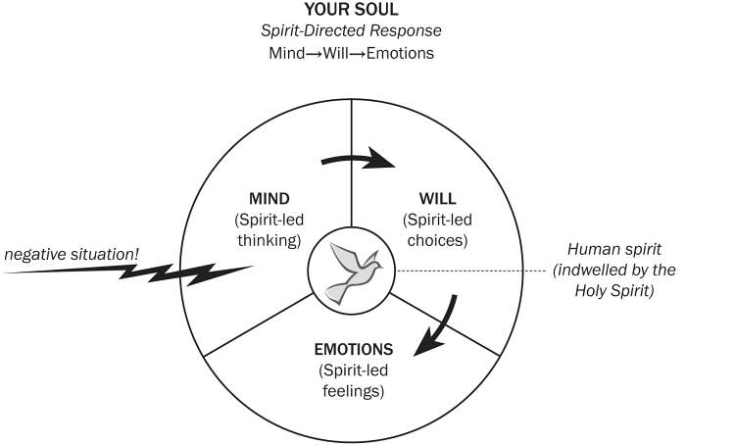
Negative Situation: Someone verbally cuts you down.

Spirit-Led Response
- Your Mind records the unjust words, the Holy Spirit, as your Counselor, teaches your mind how to think about the offense.
"The Counselor, the Holy Spirit — the Father will send Him in My name — will teach you all things and remind you of everything I have told you" (John 14:26 HCSB).
"His words were so hateful. But there must be something painfully broken in his life. I will do what the Bible tells me to do — I need to '...pray for those who persecute [me].'" (Matthew 5:44)
- Your Will acts with prayer as the Spirit directs your will toward the right choice. As your Conscience, He convicts you to pray, whether you feel like it or not.
"When he, the Spirit of truth, comes, he will guide you into all the truth. He will not speak on his own; he will speak only what he hears, and he will tell you what is yet to come" (John 16:13).
"Lord, I pray that ( name of critic ) will allow You to meet the need for healing whatever past pain is still causing ( name of critic ) problems."
- Your Emotions respond with compassion as the Spirit controls your emotions.
"Hope does not put us to shame, because God's love has been poured out into our hearts through the Holy Spirit, who has been given to us" (Romans 5:5).
As you pray, the Comforter evokes from you loving compassion toward the unjust person who is spiritually needy. ...
"... those who live in accordance with the Spirit have their minds set on what the Spirit desires ... the mind governed by the Spirit is life and peace." (Romans 8:5-6)
______________________________________________________________________________________________________________________________________________________________________________________________________________________________________________________________________________________________________________________________________________________________________________________________________________________________________________________________________________________________________________________________________________________________________________________________________________________________________________________

